Seat Critique

User Manual

This is the user manual for Seat Critique, the all in one restroom locator and review app for the University of Kansas. Our website is <http://seat-critique.gitgud-ku.com>. This guide will cover all the features of this website, and all the different ways a user can interact with it.

The first thing a new user should do is create an account. Many of the functions of this website, including creating and critiquing restrooms, will not work without an being a logged in user. This is achieved by clicking the ‘Login’ button on the top-right corner of the front page. The user will be redirected to the sign in page, and, if the user has an account, they can enter their email and password. Otherwise, new users can press ‘Sign up’ at the bottom to create a new account.

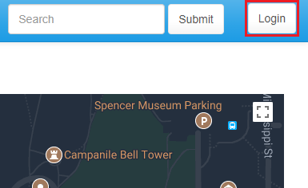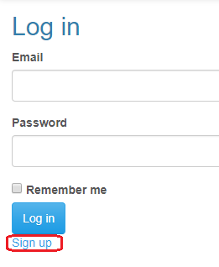

To create a new account, the user must provide an email address, password, and bathroom preference. The bathroom preference is especially important - it determines which bathrooms show up when viewing any building. Setting gender preference to ‘Male’ allows the user to view male and gender neutral restrooms; setting gender preference to ‘Female’ allows the user to view female and gender neutral restrooms. Note however, that setting preference only allows the user to see gender neutral restrooms.

While logged in, clicking the ‘account’ button in the top-right of the page allows the user to edit all of their account settings, or log out.

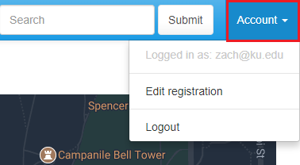

On any page, clicking the Seat Critique text in the top-left corner of the page will redirect the user back to the main page with the map.

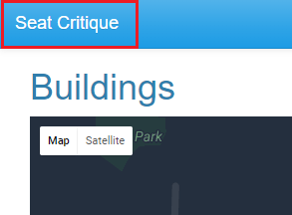

The map, visible on the front page, is the core of this product. Users may interact with the map in many ways. Clicking the square outline in the top right of the map enables fullscreen mode. Pressing ‘escape’ while in fullscreen mode returns the map to the standard view. Like with Google Maps, the user may drag the map around by holding down left click and dragging the map in any direction. The user may zoom in and out using the plus and minus buttons in the bottom-right corner, or by scrolling up or down on the mousewheel. In the top-left corner, the user may switch between map and satellite view, where satellite view uses real images instead of just a roadmap. Additionally, by dragging the human icon in the bottom right onto any street, the user may enter street view (which is really cool, try it out). The user may exit street view by clicking the arrow in the top-left of the street view screen.

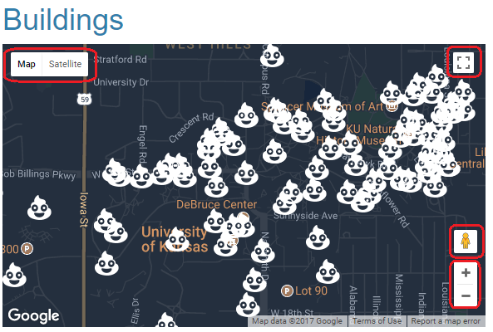

While using the map the user will likely see several white pins. There’s a bunch all over the KU Campus. They are clickable. Each one represents a different building on KU. When the user clicks one, information about that building pops up, including the name and number of registered bathrooms. Clicking the ‘show’ button in the pop-up window redirects the user to the page specific for that building.

There are two more functions available on the front page. The first one is a search bar. When any part of a building’s name is typed into this search bar, the map will automatically zoom in on the first building which contains the input in its name. It will bring up info about that building as if the user had clicked on the pin. This is a very helpful feature when trying to find a building without knowing its location.

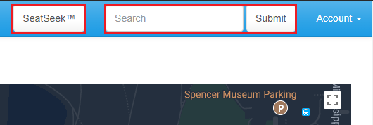

The second feature is called SeatSeek. When the SeatSeek button is pressed, the website will try to find the closest restroom to you. To do this, the user must grant permission to Seat Critique to use location tracking services. Under most browsers, a small pop up will appear with a message similar to “SeatCritique would like to know your location”. If the user clicks allow, SeatSeek will then take your location and find the closest building which has a restroom the user can use. SeatSeek is ideal for finding a restroom in a pinch, without knowing exactly where nearby ones are.

When on the buildings page, the name and address of the building will be displayed. Below those will be a list of restrooms. If the user is logged in, this list will be filtered to only the restrooms the user can use. Each restroom has its floor, overall score, location, and gender displayed. Clicking ‘Show’ will display more in-depth information about the restroom.

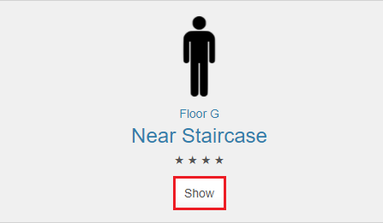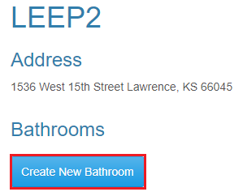

The ‘Create New Restroom’ button is the go-to option if the restroom you wish to look at or critique is not yet registered on our website. When creating a new restroom, the first three fields - gender, floor, and location - are required. Valid floor names are any positive number, B, G, L, or LL. The form will not submit properly if any other value is chosen.

Below those first three input fields are tags. These are a variety of things that some bathrooms have but others don’t. Please check the box if the restroom has that feature, and leave it unchecked if it doesn’t. It is allowed to have none of the boxes checked, if none of the conditions apply to that restroom.

On the restroom ‘Show’ page, the average score from the critique, if any, will be displayed. This is a quick way to get the general impression of any restroom. If no critiques are available, then this information will not be displayed until someone (maybe the user) creates a critique of that restroom.

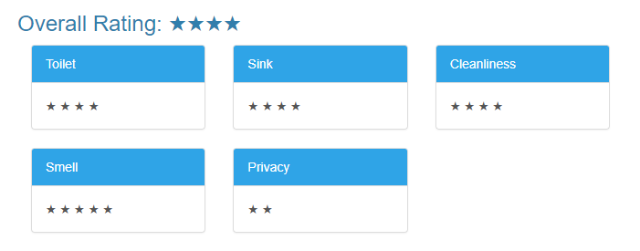

On the bottom of the restroom ‘Show’ page, there is a button to create a new critique for that restroom. If the user has already created a critique, then the user will instead have the option to edit their critique. Clicking that button in either case takes the user to the critique page.

The critique page lets the user fill out a series of 1-5 star ratings for a bathroom, for several categories. Currently, the following categories are implemented:

* Overall: Often, but not necessarily an average of the other ratings. How was the entire experience? How likely are you to return to this restroom?
* Toilet: Does the toilet flush? Is it clogged? Is it one of those automatic ones but it flushes while you’re still sitting on it? Is there enough toilet paper? Is it super loud?
* Sink: Do they work? Are they automatic? Do they have soap nearby? If they are automatic, do they shut off after a very short time? Is the water too hot or too cold? Are there not enough? Does the paper towel dispenser or automatic dryer work?
* Cleanliness: Is there writing on the wall? Do the stalls look like they need to be replaced? Is the trash can overflowing? Are the floors dirty? This rating can be very subjective.
* Smell: Self explanatory.
* Privacy: How much traffic does this restroom have? Is it outside a really popular spot? Are there not enough toilets for the traffic it has? Are there often lines or queues? Also, does it seem like everything is too close together?

